**Setting up SSH for remote admin (RSA and Ed25519)**

{Example from Linux Administration Cookbook}

RSA

Make sure you have a connection to your VM

$ ping 192.168.33.11

Generate a key pair on your host machine. The public key will be copied onto your server and private key will be on your local machine.

$ ssh-keygen -b 4096 -C “Example RSA Key”

Copy your public key onto your VM. Once your public key is on your server, you can ssh into your server using your private key on your local machine.

$ ssh-copy-id 192.168.33.11

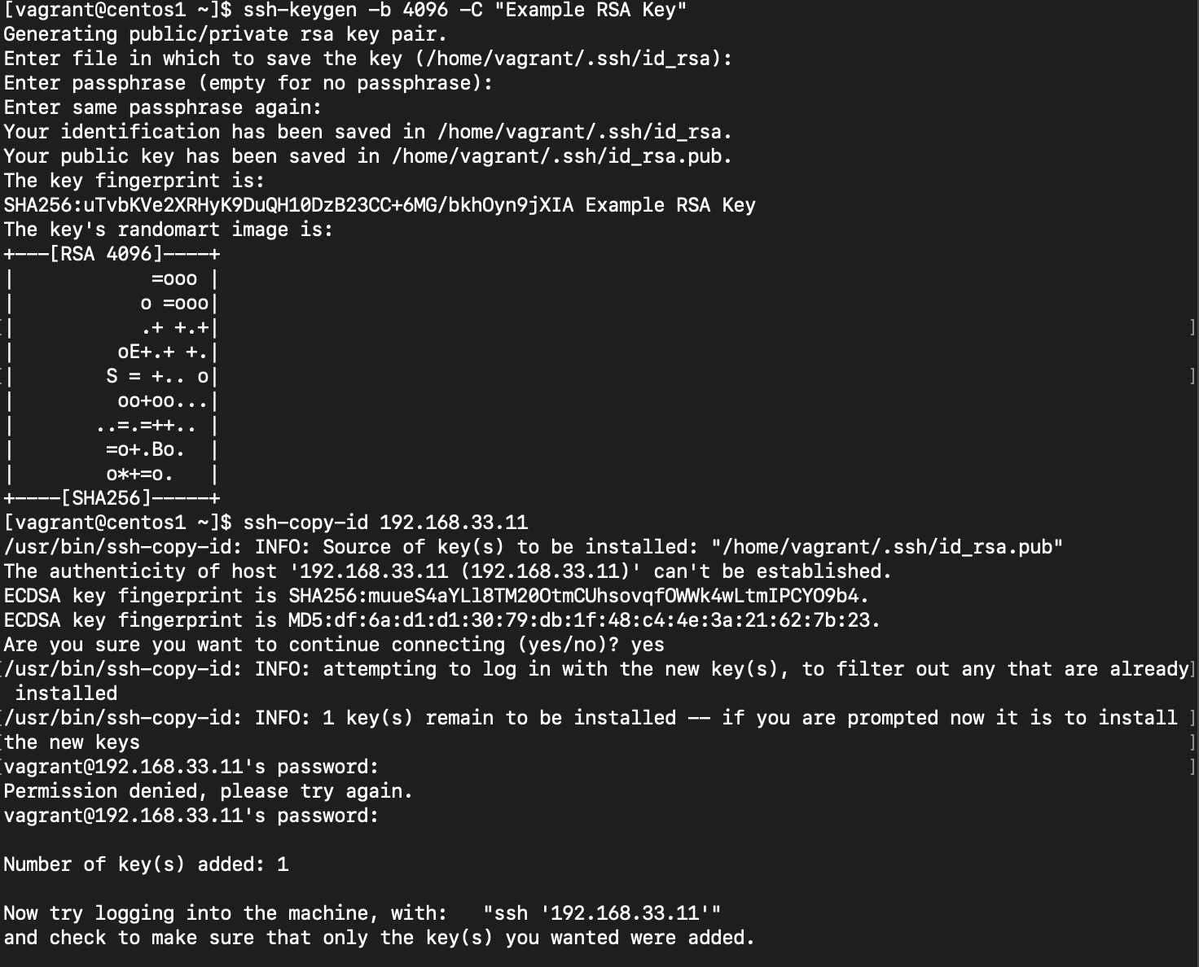

Check to see if you can ssh into your VM via key

$ ssh 192.168.33.11

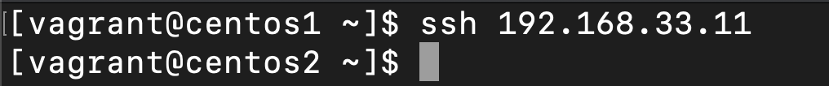

Ed25519

Make sure you have a connection to your VM

$ ping 192.168.33.11

Generate Ed25519 key

$ ssh-keygen -t ed25519 -C “Example Ed25519 Key”

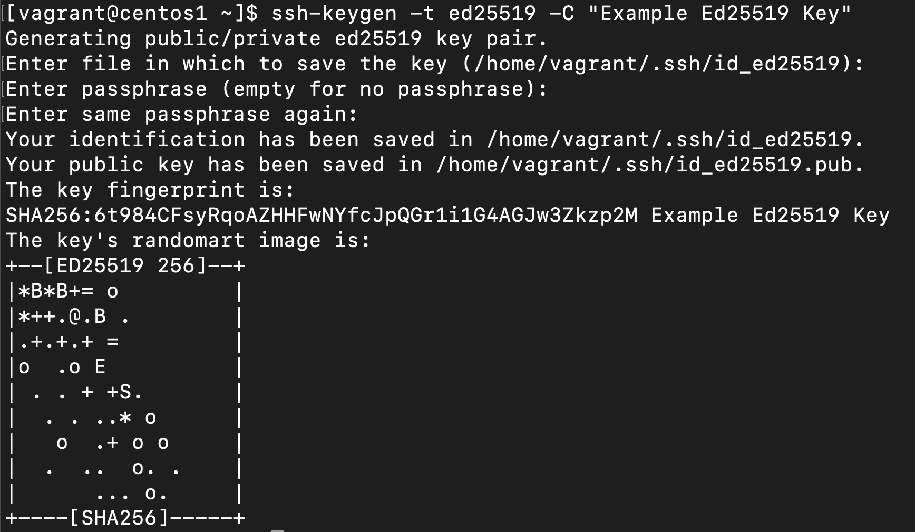

Copy your newly created public key to your VM (192.168.33.11)

$ ssh-copy-id -i .ssh/id_ed25519.pub 192.168.33.11

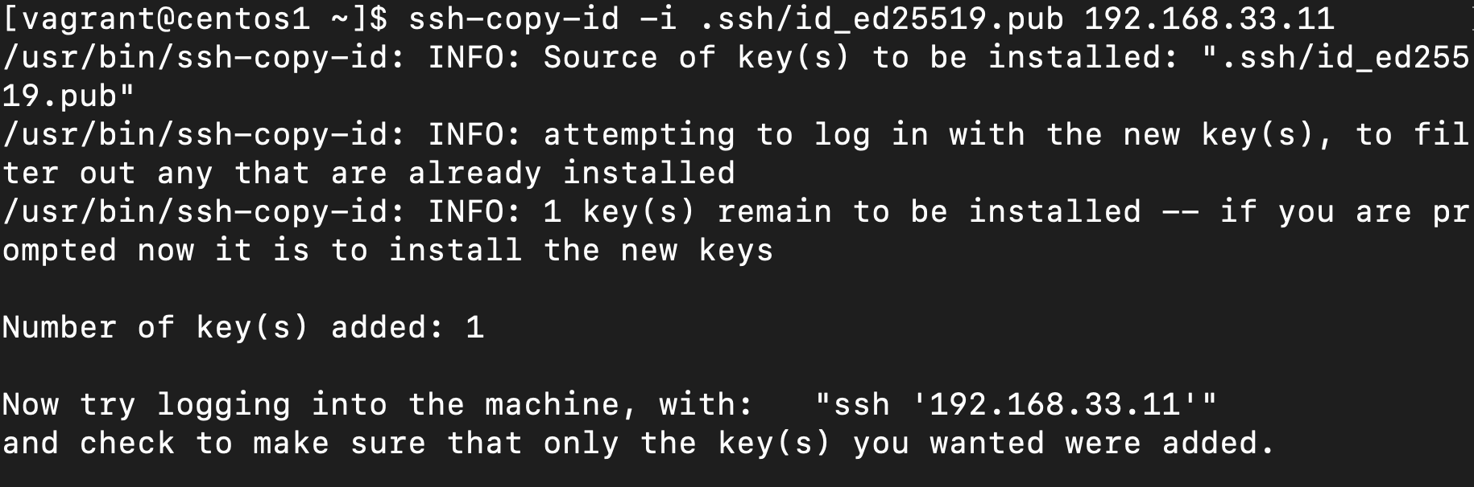

Check to see if you can ssh into your VM using your new Ed25519 key



**\*\*Make sure your ssh permissions are correct:**

**Public keys (with .pub) have 644 perms**

**Private keys have 600 perms**